The cart on a track

Author: Brent Justice

Course: AAE 36401

Date: 9/11/2014

TA: Abi Akomandu

# Introduction

# Procedure

# Results

Part (i): the open loop model

**Table 1: experimentally determined constants**

|  |  |  |
| --- | --- | --- |
| variable | units | value |
| m | kg | 1.07 |
| Bemf | kg/s | 7.72 |
| Beq | kg/s | 3.39 |
| c | kg/s | 11.11 |
| λ | N/(Ω*A) | 1.72 |

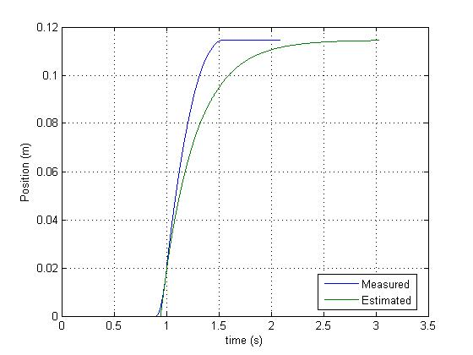

**Figure 1: position of cart over time after cart receives a “push” to simulate an impulse input**

Part (ii): model validation and saturation

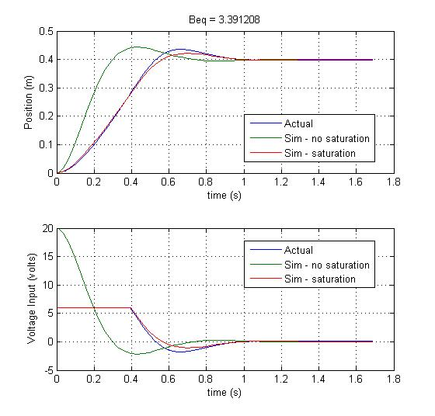

**Figure 2:** voltage input and position output with a constant gain feedback. Note that experimentally collected results are compared to simulation results.

**Table 2:** Comparison of experimentally observed value for Beq and the adjusted Beq value.

|  |  |  |
| --- | --- | --- |
| variable | units | value |
| Beq - measured | kg/s | 3.39 |
| Beq - adjusted | kg/s | 2.50 |

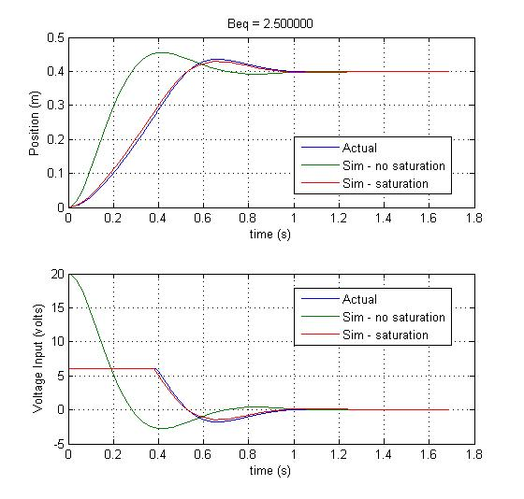

**Figure 3:** Same as Figure 2 except that Beq was tweaked to make the simulation results match the experimentally determined results.

Part (iii): the effect of coulomb friction

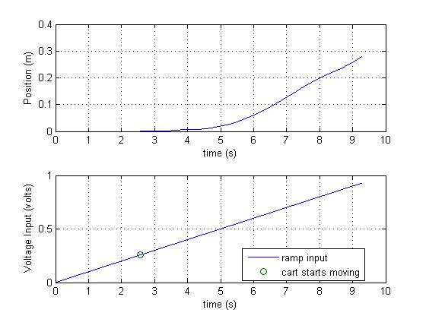

**Figure 4:** experimentally determined position output from a ramp voltage input

**Table 3:** experimentally determined coulomb friction

|  |  |  |
| --- | --- | --- |
| variable | units | value |
| fc | N*V/(Ω*A) | 0.44 |

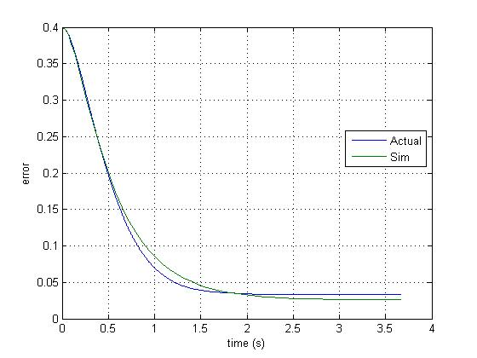

**Figure 5:** comparison of experimentally observed error and simulated error over time with a constant gain feedback on voltage input

**Table 4:** comparison of experimentally observed steady state error and theoretical steady state error

|  |  |  |
| --- | --- | --- |
| variable | units | value |
| |e(∞)| upper bound | m | 0.026 |
| |e(∞)| experimental | m | 0.033 |
| |e(∞)| simulated | m | 0.026 |

Part (iv): integral controller and coulomb friction

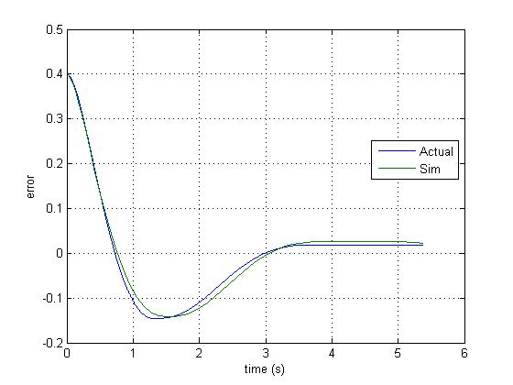

**Figure 6:** comparison of experimentally observed error and simulated error over time with a PI controller

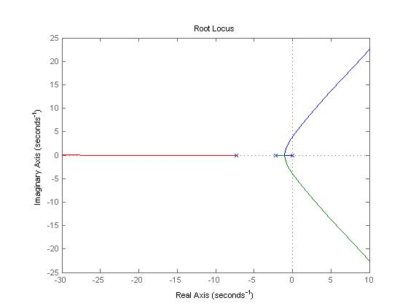

**Figure 7:** root locus illustrating values for which ki is stable

**Table 5:** largest value of ki that yields stable roots (all negative roots)

|  |  |  |
| --- | --- | --- |
| variable | units | value |
| ki - max | V/m | 51.6 |
| Resulting Roots | N*V/(Ω*A*ms) | -8.7729 |
|  |  | -0.38 + 3.05i |
|  |  | -0.378 - 3.05i |

Part (v): moving the cart with PID controller

**Table 6:** PID controller inputs prior determined with SIMULINK prior to experiment and performance parameter outputs

|  |  |  |
| --- | --- | --- |
| variable | units | value |
| PID inputs | | |
| kp | V/m | 1000 |
| ki | V/m | 20 |
| kd | V/m | 5 |
|  |  |  |
| Performance Parameters Output | | |
| tr | s | 0.6 |
| percent overshoot | % | 7.32 |
| ts | s | 0.74 |
| |e(∞)| | m | 0.003 |

# Analysis and Discussion

# Conclusion and Recommendation

# Appendix